**Week 1 – Database Planning**

1. Data Storage Techniques
   1. Basic Database Diagram

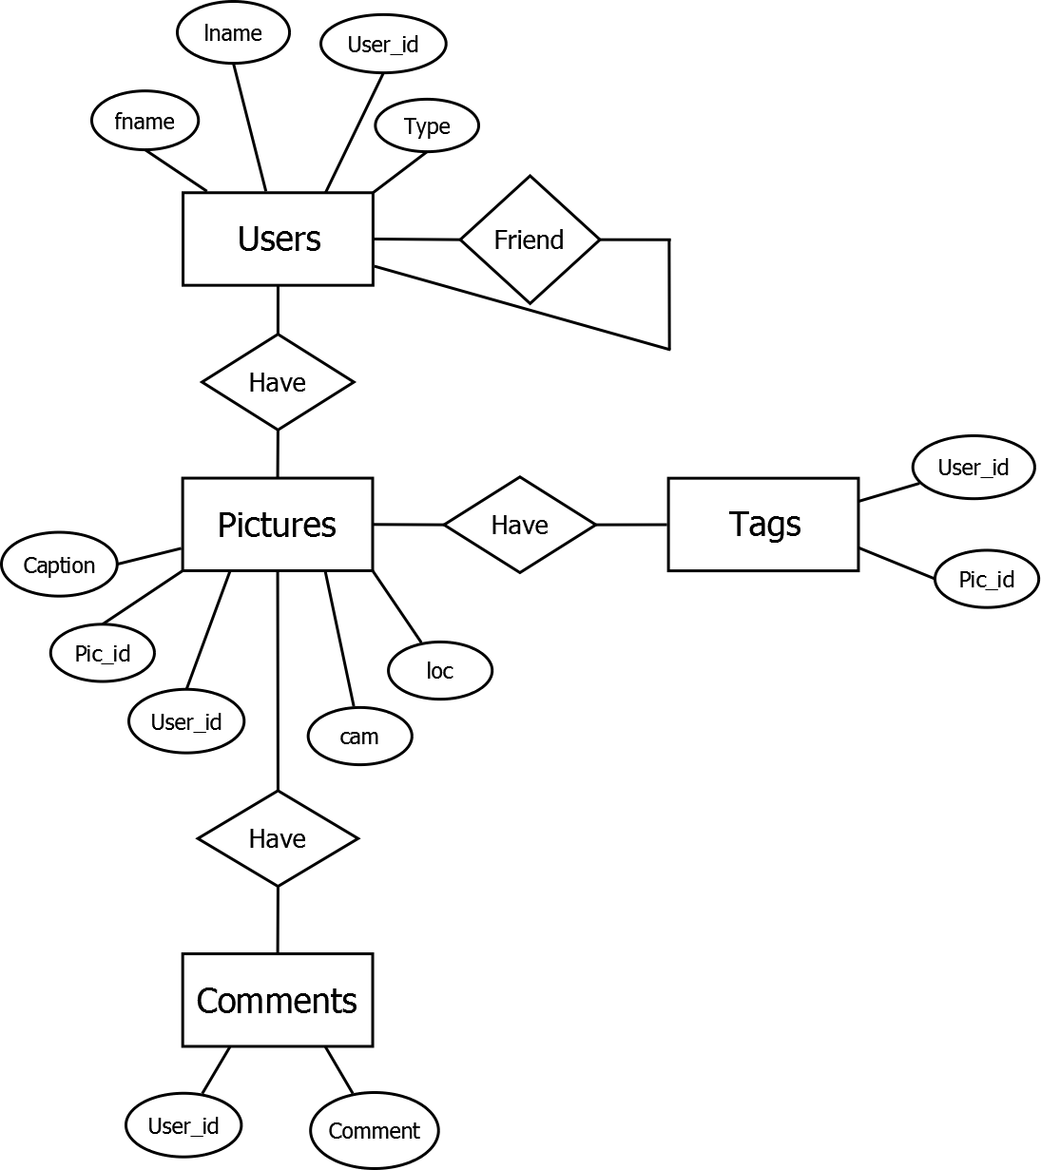

* 1. Security  
     Looking into mysql permissions and security already built into there database language.